M.A.M COLLEGE OF ENGINEERING
PROJECT NAME : CALCULATING FAMILY EXPENSES USING SERVICE NOW

TEAM MEMBERS :

1) Madhumitha B
2) Kaviya J
3) Kannika C
4) Karthika B

calculating Family Expenses using Service Now
The project aims to develop a comprehensive expense calculation system using ServiceNow. This system will enable users to track and manage family expenses efficiently. It will include features such as expense categorization, budget setting, real-time tracking, and reporting capabilities. Utilizing ServiceNow's robust platform, the project will ensure seamless integration, user-friendly interface, and scalability to accommodate varying family sizes and financial complexities. The end goal is to empower users with the tools they need to make informed financial decisions and promote financial well-being within the family unit.

Setting up ServiceNow Instance
1 . Sign up for a developer account on the ServiceNow Developer site "https://developer.servicenow.com".
- Once logged in, navigate to the "Personal Developer Instance" section.
- Click on "Request Instance" to create a new ServiceNow instance.
- Fill out the required information and submit the request.
- You'll receive an email with the instance details once it's ready.
- Log in to your ServiceNow instance using the provided credentials.
- Now you will navigate to the ServiceNow.

Creation of New Update Set
1. Go to All >> In the filter search for Local Update set > click on New.
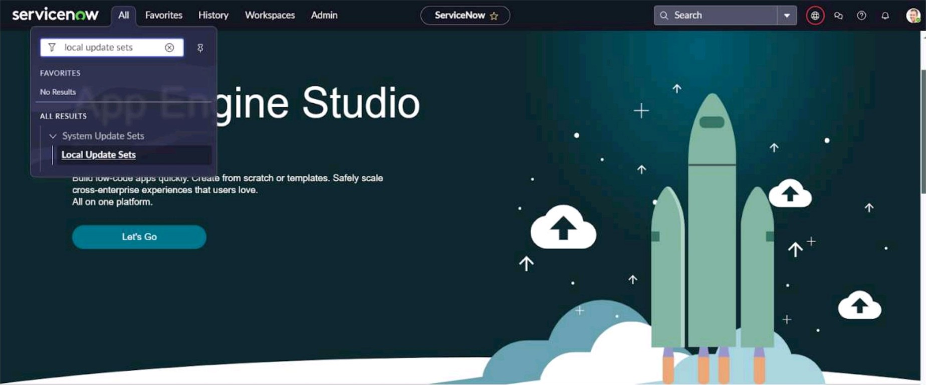
Go Further
Enter the Details as:
Name : Family Expenses
Then click on Submit and Make current
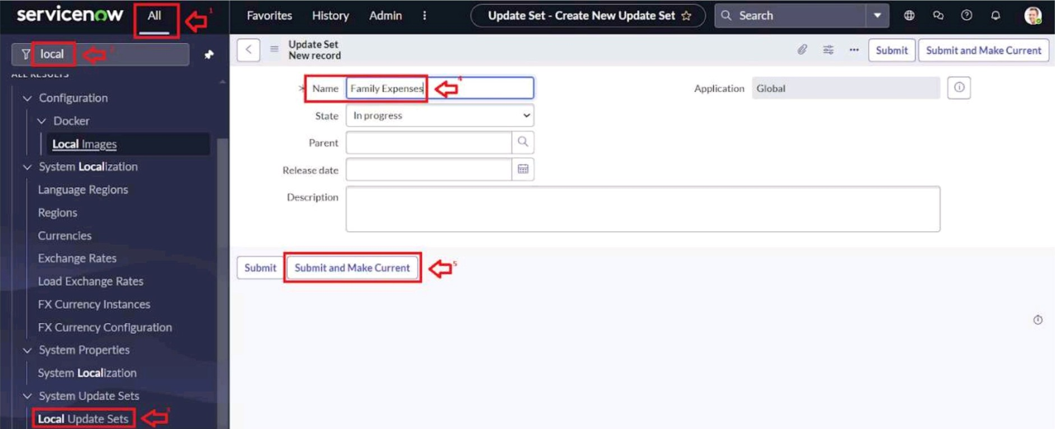

Creation of Family Expenses Table
1 . Go to All > In the filter search for Tables > click on New.
2. Enter the Details: Label : Family Expenses
Name : Auto-Populated
New menu name : Family Expenditure
Label | Family Expenses
Application Global
Name u_st_family_expenses
* Remote Table
Create module

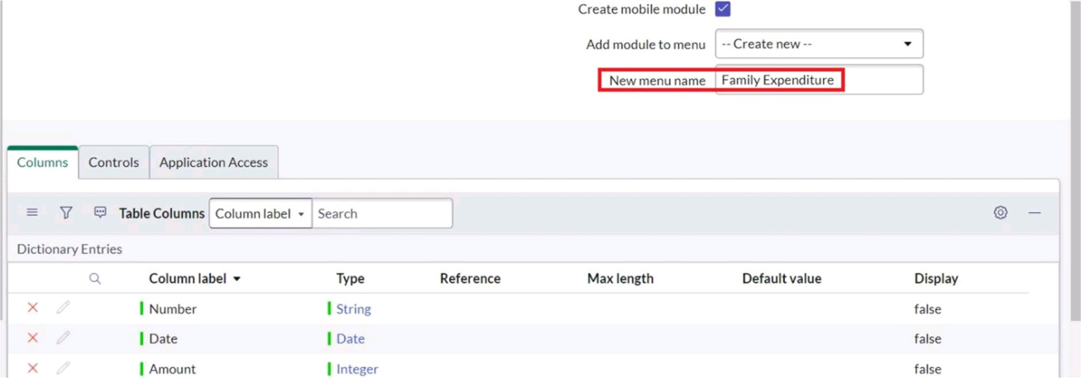
3. Co to the Header and right click there>> click on Save.

Creation of Columns(Fields)
- Near Columns Double click near insert a new row.
- Give the details as:
Column label : Number
Type : String
- Double click on insert a new row again
- Give the details as:
Column label : Date
Type : Date
- Double click on insert a new row again
- Give the details as:
Column label : Amount
Type : Integer
- Double click on insert a new row again
- Give the details as:
Column label : Expense Details
Type : String
Max length : 800
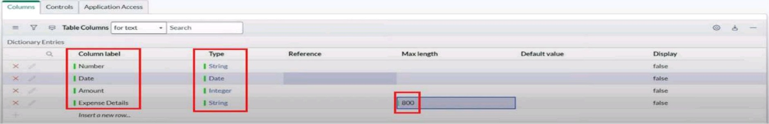
- Co to the Header and right click there>> click on Save.

Making Number Field an Auto-Number
1 .Double click on the Number Field/Column.
2.Go down and double click on Advanced view
3.1n Default Value:
Use dynamic default : check the box
Dynamic default value : Get Next Padded Number
4.Click on Update.
Default Value
Choice List Specification Calculated Valu
Jhe Default value specifies what value the held has when first displayed.
o
Delete Column | Update
5.Go to All >> In the filter search for Number Maintenance >> select Number Maintenance
6.Click on New.
7.Enter the below Details: Table : Family Expenses
Prefix : MFE
1.000
Number
Application Global
7
Numberofdigits
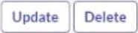
8.Click on Submit

Configure the Form
1 . Go to All >> In the filter search for Family Expenses >> Open Family Expenses
- Click on New
- Go to the Header and right click there>> click on Configure >> Select Form Design
- Customize or Drag Drop the form as per your requirement.
2 Column v
Number Date
Amount
1 Column v
Expense Details
- Make Number Read-Only Field by clicking on the gear icon and checking Read-Only
- Make Date, Amount Mandatory Field by clicking on the gear icon and checking Mandatory
- Click on Save.

Creation of Daily Expenses Table
1 . Go to All > In the filter search for Tables > click on New.
- Enter the Details:
Label : Daily Expenses
Name : Auto-Populated
Add Module to menu : Family Expenditure
Acvlication Global
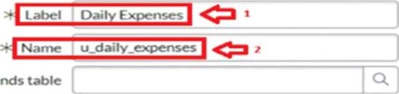
Extends table 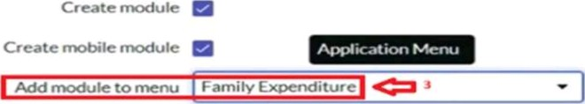

- Co to the Header and right click there>> click on Save.

Creation of Columns(Fields)
- Near Columns Double click near insert a new row.
- Give the details as: Column label : Number
Type : String
- Double click on insert a new row again
- Give the details as: Column label : Date
Type : Date
- Double click on insert a new row again
- Give the details as: Column label : Expense
Type : Integer
- Double click on insert a new row again
- Give the details as:
Column label : Family Member Name
Type : Reference
Max length : 800
- Double click on insert a new row again
1 0. Give the details as: Column label : Comments
Type : String
Max length : 800
1 1 . Go to the Header and right click there>> click on Save.

Making Number Field an Auto-Number
1 . Double click on the Number Field/Column.
- Go down and double click on Advanced view
- In Default Value:
Use dynamic default : check the box
Dynamic default value : Get Next Padded Number
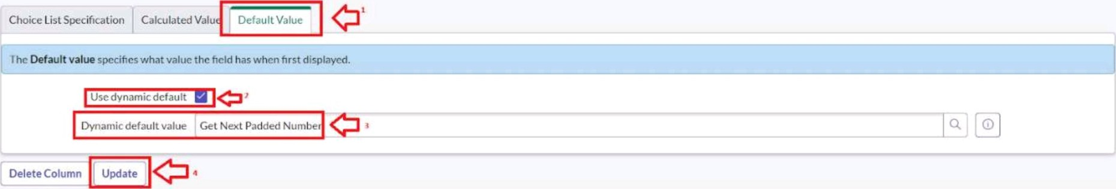
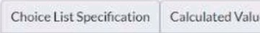
- Click on Update.
- Go to All >> In the filter search for Number Maintenance >> select Number Maintenance
- Click on New.
- Enter the below Details:
Table : Family Expenses prefix : MFE
9. Click on Submit.

Configure the Form
1 . Go to All >> In the filter search for Daily Expenses >> Open Daily Expenses
2. Click on New
3.Go to the Header and right click there>> click on Configure >> Select Form Design
4.Customize or Drag Drop the form as per your requirement.
5.Make Number Read-Only Field by clicking on the gear icon and checking Read-Only
6.Make Date, Family Member Name Mandatory Field by clicking on the gear icon and checking Mandatory
7.Click on Save.

Creation of Relationship between Family Expenses and Daily Expenses tables
1 . Go to All >> In the filter search for Relationships >> Open Relationships
- Click on New.
- Enter the details: Go to All >> In the filter search for Business Rules.
- Under System Definition Select Business Rules then click on New.
- Enter the Details:
Name : Daily Expenses
Applies to table : Select Family Expenses
Daily Expenses : Select Daily Expenses
6.Click Save.

Configuring Related List on Family Expenses
1 . Go to All >> In the filter search for Family Expenses >> Open Family Expenses
- Click on New
- Go to the Header and right click there>> click on Configure >> Select Related Lists
- Add Daily Expenses to the Selected Area.
- Click on Save
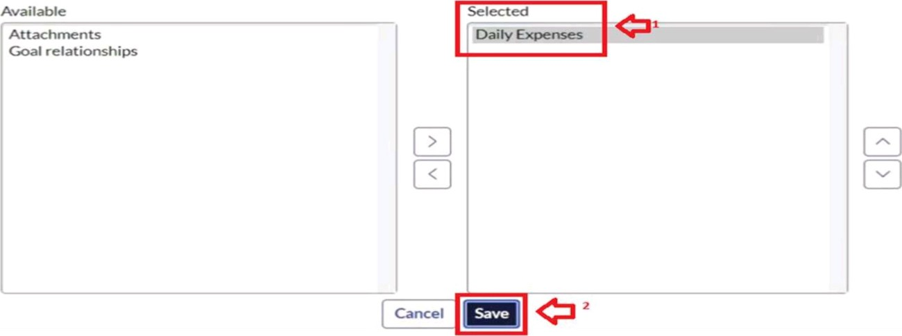

Creation of Business Rules
1 . Go to All >> In the filter search for Business Rules.
- Under System Definition Select Business Rules then click on New.
- Enter the Details: Name : Family Expenses BR
Table : Select Daily Expenses
Check Advanced
Business Rule
New record
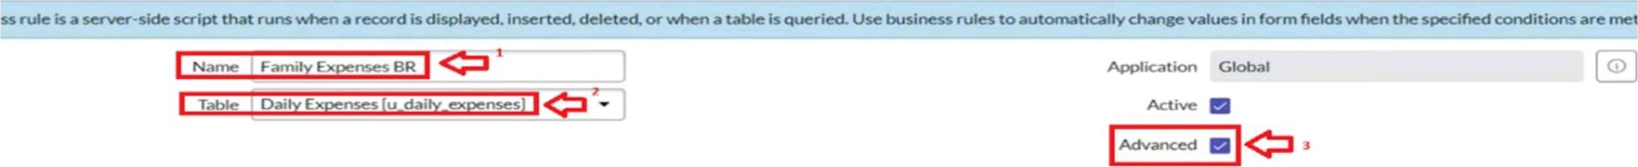
5. In Advance(we write the code): Write the below code >>
(function executeRule(current, previous /*null when async*/) {
var FamilyExpenses = new
FamilyExpenses.addQuery(Iu_dateI,current.u_date); FamilyExpenses.query(); if(FamilyExpenses.next())
FamilyExpenses.u_amount += current.u_expense;
+=
FamilyExpenses.update();
else
var NewFamilyExpenses = new
NewFamilyExpenses.u_date = current.u_date;
NewFamilyExpenses.u_amount = current.u_expense; NewFamilyExpenses.u_expense_details +=
NewFamilyExpenses.insert();
l) (current, previous);
6. Co to the Header and right click there>> click on Save

Configure the Relationship
- Go to All >> In the filter search for Relationships >> Open Relationships.
- In that, open Daily Expenses Relationship.
- For Applies to table : Select Family Expenses.
- In Query with : write the below Query.
(function refineQuery(current, parent) {
// Add your code here, such as current.addQuery(field, value); current.addQuery('u_date',parent.u_date);
current.query();
})(current, parent);
- Click on Update.

